1. **What was the most impactful thing(s) you learned this week and why do you think so?**

**These weeks have been a bit chaotic for me, to be honest, I have not been able to study the topics in-depth, so every time I read or review the material, I learn something new, that being said this week I learned about Lighthouse, although I understand the general notion of its usefulness, I feel that with respect to the other topics I need more practice**

1. **What questions do you have about this week's chosen topic(s) and/or exercises (first-time students) or websites you are working on (repeat students)?**

**I don't have questions or doubts that I can't solve, rather it would be problems to use the cmd in the various tasks I usually get lost and confused a bit but with some time I usually solve these problems.**

1. **Would you like specific feedback from your instructor? If so, what things would you like feedback on? (Please use the Canvas calendar to schedule time to meet with your instructor or attend a study session.)**

**I have been looking for information in my own language for some parts of the assignments if I knew of any other books(like Novice to Ninja) that I could consult (preferably in Spanish) that would be fantastic.**

1. **Where would you go next to learn more about this week's topic(s)? Give 2-3 links to resources that look promising to help answer the questions you indicated in the quiz question above.**

[**https://www.sitepoint.com/premium/books/jump-start-web-performance/read/2/**](https://www.sitepoint.com/premium/books/jump-start-web-performance/read/2/)

[**https://cmacomunicacion.com/google-lighthouse-todo-lo-que-debes-saber/#:~:text=Lighthouse%20de%20Google%20es%20una,rendimiento%20del%20sitio%20que%20deseemos**](https://cmacomunicacion.com/google-lighthouse-todo-lo-que-debes-saber/#:~:text=Lighthouse%20de%20Google%20es%20una,rendimiento%20del%20sitio%20que%20deseemos)**.**

1. **Did you participate with the class on Slack? (You can participate by asking a question, answering a question, or sharing a resource you’ve found. Or you can share your thoughts on what you’re learning this week. Or you can answer any questions your instructor might have given in their announcement.)**

**I usually check the videos and information they share but I haven't uploaded anything or helped someone solve their doubts yet.**

1. **Please rate your success with learning and this week’s work on a scale of 1 to 4.**

4

* Please rate yourself at the level you feel most closely matches your learning; 1 is the lowest rating and 4 is the highest.
* Feel free to use decimals if you feel you must.
* Your answers to questions 1 through 4 are your justification for your rating.
* This is most of your grade for your reflection, you also receive one point for submitting the other required items.
  + Your instructor won’t grade your assignment until you submit the required items (screenshot, zipped files, etc.)
* If your instructor disagrees substantially with your rating, they can raise it or lower it to signal to you their expectations.
* If your instructor lowers your rating, your instructor might contact you to arrange a meeting to see how they can help you. Feel free to reach out to them as well.

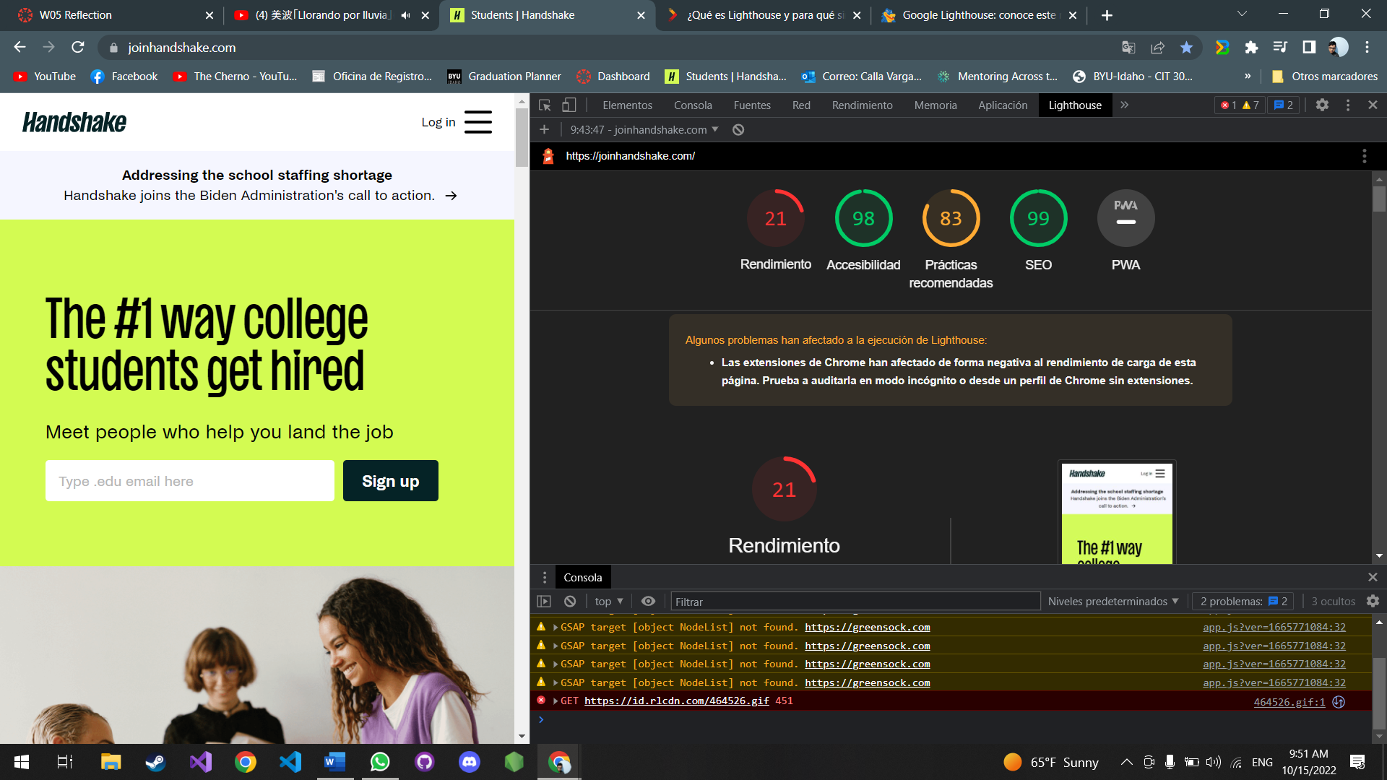

Reviewing the information in the book and other resources, the following is concluded: the performance is very low if the metric is reviewed, it is concluded that some things must be improved, such as the content in CSS that is not used as well as in JavaScript, as well as the elimination content that blocks rendering. With respect to Accessibility and SEO points that are very good, what should be improved is the relationship between the contrast of the colors of the background and the foreground and resizing the size of the touch elements respectively.

In Best Practices, although the number is high, there are still improvements, and errors were detected such as errors in the console browser (they do not load some resources) and there is no security regarding XSS attacks.